**Day 4 tasks - Output**

1. **Program in anonymous function & IIFE:**
2. **Print odd numbers in an array**



1. **Convert all the strings to title caps in a string array**



**C) Sum of all numbers in an array**

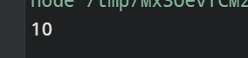

**D) Return all the prime numbers in an array**



**E) Return all the palindromes in an array**

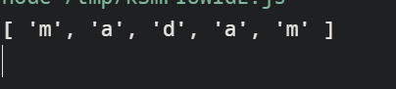

1. **Return median of two sorted arrays of the same size.**

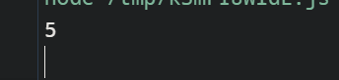

1. Remove duplicates from an array

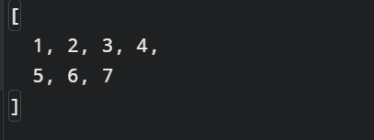

1. Rotate an array by k times

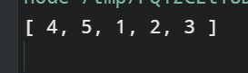

1. **Program in arrow function:**

**a) Print odd numbers in an array**



b) **Convert all the strings to title caps in a string array**



**C) Sum of all numbers in an array**



**D) Return all the prime numbers in an array**



**E) Return all the palindromes in an array**

